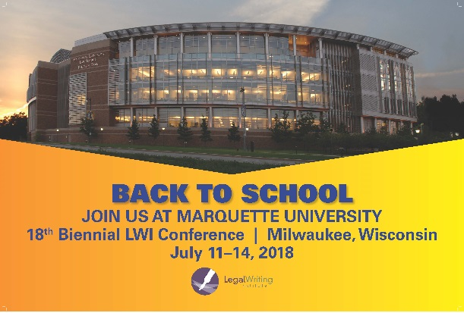
Giving Back to the Conference Host Community–Pro Bono Projects for Milwaukee Non-Profit Organizations

As part of the upcoming 18th Biennial LWI Conference in Milwaukee in July 2018, your conference planners would like LWI to contribute to the Milwaukee community by tapping into the developing research and writing skills of our students. To that end, we are seeking legal writing faculty from across the country to be part of a pilot program in which participating faculty will work with students at their own law schools on pro bono projects for “partner” organizations in the greater Milwaukee, Wisconsin area. The students’ final work will be presented to the partner organizations at a reception on Tuesday evening, July 10, 2018, just prior to the start of the LWI conference.

Background information:

As you may already know, non-profit organizations providing legal services often do not have access to in-depth research on specific subject areas and/or rely on the pro bono services of volunteer attorneys who are competent lawyers but often unfamiliar with the legal issues confronting the poor and disenfranchised. For example, volunteer attorneys may be well versed in mergers and acquisitions but unfamiliar with the workings of the court that hears landlord-tenant disputes or how to probate a will. Our students can help fill this gap by providing research assistance through pro bono projects.

Details of the project:

The pilot program will be modeled on a project developed three years ago at Georgetown Law in which first-year legal research and writing students provide much-needed research for the Catholic Charities Legal Network in the Washington metropolitan area. Working in groups of 4-6, students research an assigned area of law in a local jurisdiction relying primarily on free and low- cost legal sources, draft a brief overview of that area of law, and create a handbook for attorneys who handle cases on that subject. The handbooks typically contain the overview; relevant statutory and regulatory provisions; and pertinent information about the court with jurisdiction over the case, including sample forms. Students also provide a list of questions to be asked during client intake and provide a list of resources that clients are likely to find helpful. During the spring semester, students donate approximately 10 hours of their time completing these projects, 4-6 hours allotted during class and 4 hours outside of class.

Invitation to participate:

We are looking for 6-8 faculty willing to incorporate this kind of project into their Spring 2018 legal research and writing course. We plan to accept participants largely on a first-come, first-served basis, but we hope to include faculty from a variety of schools and geographic locations. We will assist participating faculty with everything they need to complete the project, including introducing them to the Milwaukee partner organization to be served, identifying the assigned area of law to be researched, and providing them with lesson plans, suggested timeframes for the project, assignment memos and other supporting documentation, research assistance, and sample handbooks.

Faculty interested in participating in the pilot program should email Fran DeLaurentis at fcd@law.georgetown.edu by August 1st. In addition to indicating your interest, please include the number of students you anticipate working on the project and whether you plan on attending the LWI conference in July 2018. If you have any questions, please feel free to contact Fran DeLaurentis, Chair of the Milwaukee Pro Bono Project Committee, at fcd@law.georgetown.edu.

