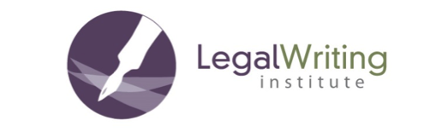
2020 Sirico Scholars’ Workshop
Application Form

Please return this application by email to Ken Chestek (kchestek@uwyo.edu)

Name:
Law School Affiliation:
Mailing Address:
Email Address:
Telephone Number:

1. Are you a full-time faculty member?

2. For how many years have you been teaching legal writing?

3. Is scholarship a requirement for your retention, promotion, or tenure? Please explain your individual situation.

4. Describe your writing project in as much detail as possible.

5. Describe how far along you are in completing your project. For examples: Do you have a detailed outline, a first draft, or substantial parts of a first draft? Please estimate how far along you will be by early July 2020.

6. Is there anything else you want to tell us?

